Chapter 10: Building the regression model II: Diagnostics

10.1 Model adequacy for a predictor variable – added variable plots

Review:
- Extra sum of squares: Measurement of the reduction of the sums of squares when a predictor variable is added to the model given a set of predictor variables are already in the model. For example, SSR(X₂|X₁) = SSE(X₁) – SSE(X₁,X₂).
- e_{i} vs. X_{ik} plot (residuals vs. k^{th} predictor variable): Determine the appropriateness of the specified relationship between X_{k} and Y. For example, if there is a random scattering of points, the relationship between X_{k} and Y is specified correctly. If there is a relationship between the points of e_{i} vs. X_{ik} (for example, a quadratic relationship), this suggests X_{ik} is not specified correctly in the model.

The problem with #2 is that it does not necessarily give information about the relationship between X_{k} and Y given all of the predictor variables in the model.

Solution: Use added variable (partial regression) plots.

Suppose there are only two predictor variables – X₁ and X₂. The steps to create an added variable plot for X₁ are:
- Find the sample regression model using Y as the response variable and X₂ as the predictor variable. Obtain the residuals. Symbolically, 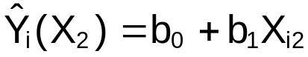 and 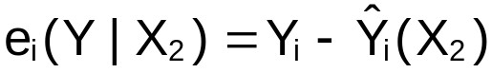. This is like removing the effect of X₂ on Y.
- Find the sample regression model using X₁ as the response variable and X₂ as the predictor variable. Obtain the residuals. Symbolically, 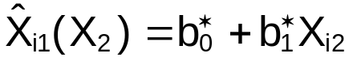 and 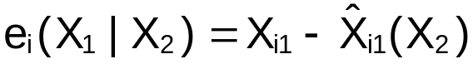. This is like removing the effect of X₂ on X₁.
- Plot 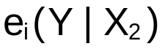 vs. 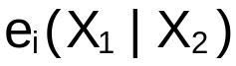.

If there are more than two predictor variables in the model, then plot 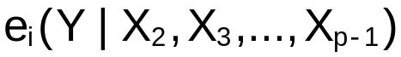 vs. 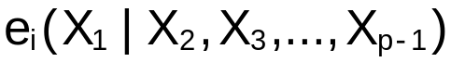. In addition, make the appropriate changes to construct added variable plots for X₂, X₃,…, X_{p-1}.

Interpretation:

The added variable plot helps to find the correct functional form of a predictor variable in a multiple regression model.

Suppose the only predictor variables are X₁ and X₂. Below are example of added variable plots:
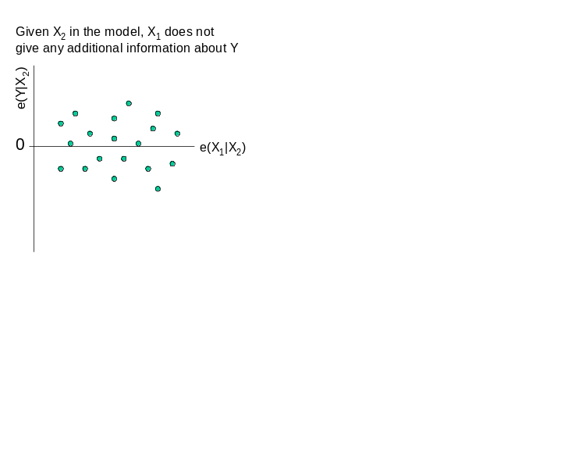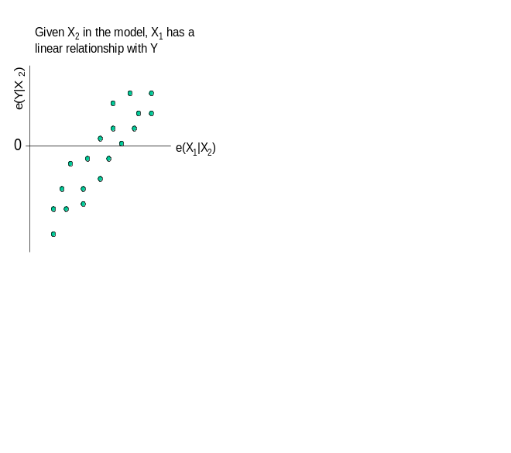
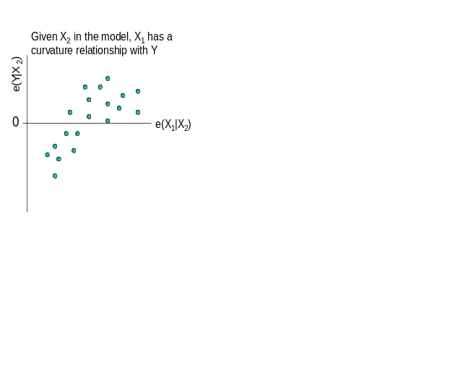

Notes:
- Notice how interpreting these plots is somewhat different from interpreting plots of e_{i} vs. X_{ik}.
- Remember what a t-test does – it tests the linear relationship between Y and X_{k} given all of the other variables in the model. Therefore, the added variable plots and t-tests partially give the same information. With the added variable plots, there is also information about the type of relationship between Y and X_{k}.
- The added variable plots are dependent on which predictor variables are present in a model.
- See Figure 10.2 of KNN for an additional interpretation of added variable plots. This further helps to relate added variable plots to extra sum of squares.
- Added variable plots also help to identify outliers and “leverage” or influential points (more on this later).
- Fox (2002) also discusses “component + residual” plots, which are similar to added variable plots. The y-axis is an approximation to the y-axis for the added variable plot. The x-axis is the unadjusted variable of interest. See p. 210 of Fox’s book for more information.

Example: NBA guard data (nba_ch10.R)

From using the model selection procedures in Chapter 9, the “best” model so far includes the variables MPG, Height, FGP, and Age. Next, we want to determine if changes to the predictor variables need to be made.

The av.plots() function in the car package automatically produces these plots.

> nba<-read.table(file =
"C:\\chris\\UNL\\STAT870\\Chapter6\\nba_data.txt",
header=TRUE, sep = "")
> head(nba)
last.name first.initial games PPM MPG height FTP FGP age
1 Abdul-Rauf M. 80 0.5668 33.8750 185 93.5 45.0 24
2 Adams M. 69 0.4086 36.2174 178 85.6 43.9 30
3 Ainge D. 81 0.4419 26.7037 196 84.8 46.2 34
4 Anderson K. 55 0.4624 36.5455 185 77.6 43.5 23
5 Anthony G. 70 0.2719 24.2714 188 67.3 41.5 26
6 Armstrsong B.J. 81 0.3998 30.7654 188 86.1 49.9 26

> mod.fit<-lm(formula = PPM ~ MPG + height + FGP +
age, data = nba)
> library(car)
> avPlots(model = mod.fit)


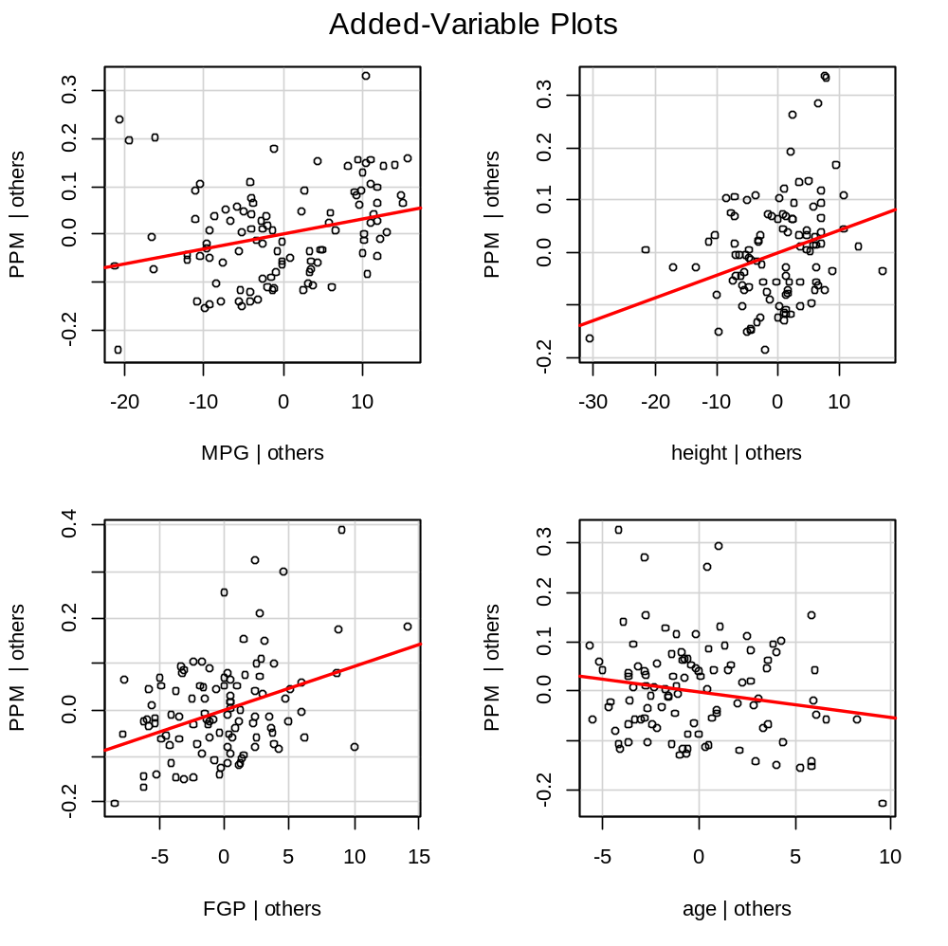

The solid line is a simple linear regression model for the y and x-axis values.

Plots discussion:
- (1,1): At least a linear relationship, maybe (?) a quadratic relationship.
- (1,2): A linear relationship
- (2,1): A linear relationship
- (2,2): Possibly a linear relationship (maybe not much of one at all)

10.2 Identifying outlying Y observations – studentized deleted residuals

When there is only 1 predictor variable, identifying outliers is not too difficult. Below is a partial reproduction of Figure 10.5 in KNN:
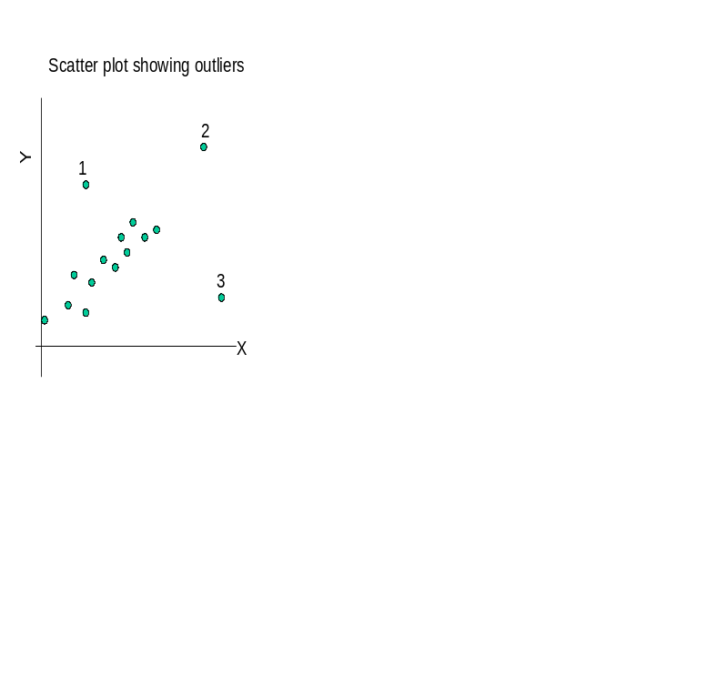
- Outlying point with respect to its Y value. May not be very influential to the regression model fit since there are similar X values.
- Outlying point with respect to its X and Y value. May not be very influential to the regression model fit since the Y value is consistent with the others.
- Outlying point with respect to its X value. May be influential since the X value is outlying and not consistent with respect to the other X values.

In multiple regression, we generally can not look at plots as shown above (too many dimensions). Therefore, we need to examine numerical measures that give information about a particular observation being outlying or not.

Residuals and semistudentized residuals (Chapters 1 and 3)

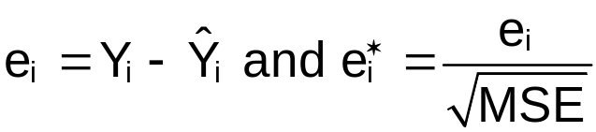

Remember that MSE is not quite the estimated variance of e_{i}. Thus,  is not quite a random variable with variance of 1.

Hat matrix (Chapters 5 and 6)

Remember that:

H=X(X′X)⁻¹X′, ,
Cov(e) = σ²(I-H), and 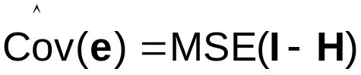

Note that H is a n×n matrix with elements of
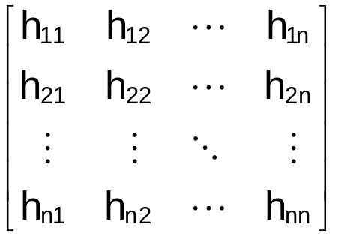

And, Cov(e) is

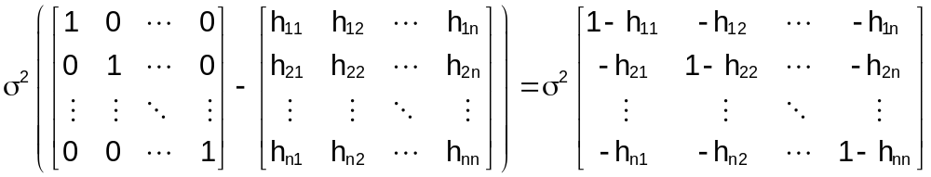
Thus, Cov(e₁, e₁) = Var(e₁) = σ²(1-h₁₁), Var(e₂) =
σ²(1-h₂₂), … Var(e_{n}) = σ²(1-h_{nn}). In general, Var(e_{i}) = σ²(1-h_{ii})

The estimated variance of the i^{th} residual is

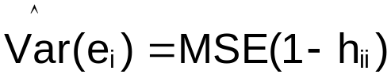

The studentized residual is:

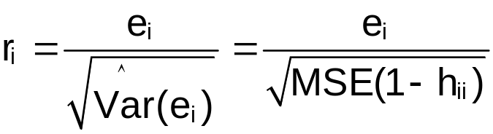 and r_{i}~t(n-p)

Notes:
- How would you detect outliers with this measure?
- The mean of the r_{i} values, 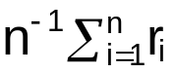, will not necessarily be 0
- We will no longer examine semi-studentized residuals ().

Deleted residuals

From Chapter 9, PRESS prediction error = Y_{i} - 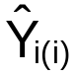

Example: Let i=3. Then the PRESS prediction error = Y₃ - 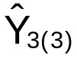. To obtain , a regression model is fit to the data where observation 3 is removed from the data set. For observation 3’s X₁,…,X_{p-1}, the predicted Y value, , is obtained.

KNN calls d_{i} = Y_{i} - the deleted residual for the i^{th} observation.

Notes:
- Suppose X_{i} is very influential on the regression model fit (for example, point #3 on p. 10.6). Then the regression line will be “pulled” toward (X_{i},Y_{i}) resulting in a 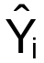 “close” to Y_{i}. If this observation is deleted from the data set and a new regression model is fit, will not be as “close” to Y_{i}. This will result in a d_{i} that is larger (in absolute value) than e_{i}.
- Suppose X_{i} is not very influential on the regression model fit (for example, a point within the main cluster of points on p. 10.6). The regression line will not be heavily influenced by (X_{i},Y_{i}). Thus, d_{i} should be about the same as e_{i}.

From Section 6.7, the estimated variance of a “new” observation is

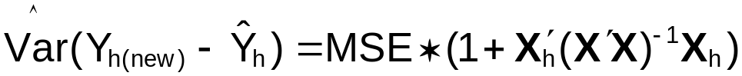

for X_{h}=(1, X_{h1}, X_{h2}, …, X_{h,p-1})′. This variance is used in calculating prediction intervals.

Since the i^{th} observation is removed from the data set in calculating d_{i}, the i^{th} observation can be thought of as a “new” observation and the estimated variance from Section 6.7 can be used for its variance. Thus, the studentized deleted residual is:

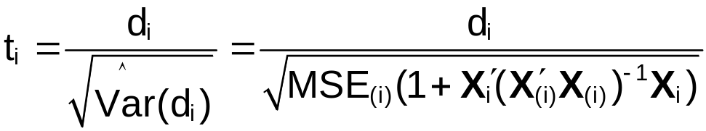

where MSE_{(i)} is the MSE from the model where the i^{th} observation is deleted. Also, X_{(i)} has the row of X corresponding to the i^{th} observation deleted. Note that t_{i}~t(n-p-1) where the degrees of freedom comes from n-1 observations and p parameters.

It can be shown that

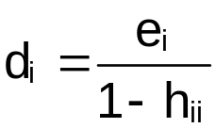

so that fitting n different regression models is not necessary to calculate d_{i}. Also, 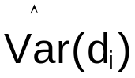 can be found by using the result

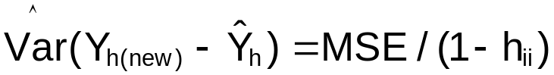

from earlier. Thus, the studentized deleted residual can be rewritten as:

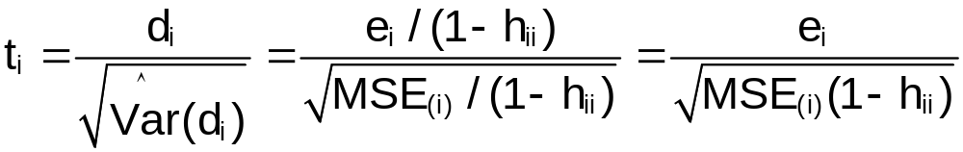

One more expression can be found for the studentized deleted residuals! Note that

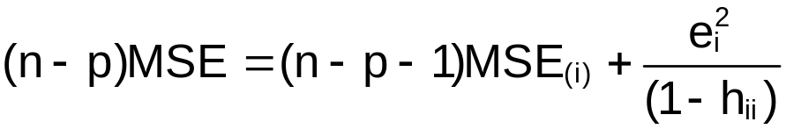

Thus,

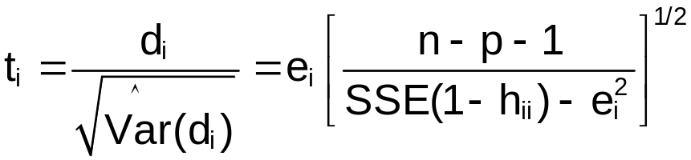

Therefore, n different regression models DO NOT need to be fit!

Test for outlying Y observations

KNN recommend doing the following (p. 396) for studentized deleted residuals:

Use a Bonferroni critical value of t[1-α/(2n); n-p-1] to determine if the observation is an outlier. In other words, H_{o}: Not outlier vs. H_{a}: outlier. If

-t[1-α/(2n); n-p-1] < t_{i} < t[1-α/(2n); n-p-1]

then there is not sufficient evidence that the i^{th} observation is an outlier. Otherwise, if t_{i} does not fall within the above interval, then the i^{th} observation is an outlier.

Use the same method for studentized residuals, but with n-p degrees of freedom.

Problem: t[1-α/(2n); n-p-1] typically is large since the number of tests being done is n (n is equivalent to g in Chapter 4). Therefore, this procedure will be VERY conservative.

Advice:
- Use KNN’s Bonferroni procedure.
- Also, examine t[1-α/2; n-p-1] as the critical value. If |t_{i}| > t[1-α/2; n-p-1], then the i^{th} observation should be investigated further as a “possible” outlier. Use a small α level for this procedure (α≈0.01).

Question: Suppose everything is o.k. with a model. Should one expect to see any |t_{i}| > t[1-α/2; n-p-1] or |r_{i}| > t[1-α/2; n-p]?

Example: NBA guard data (nba_ch10.R)

The studentized and studentized deleted residuals can be found from the rstandard() and rstudent() functions, respectively. Note that this is somewhat confusing which function gives what measure!

> mod.fit

Call:
lm(formula = PPM ~ MPG + height + FGP + age, data = nba)

Coefficients:
(Intercept) MPG height FGP age
-0.764257 0.003132 0.004337 0.009520 -0.005188

> #Studentized and studentized deleted residuals
> r.i<-rstandard(model = mod.fit)
> t.i<-rstudent(model = mod.fit)

> r.i[1:5]
1 2 3 4 5
1.22842017 0.26302737 0.09304872 0.15655550 -1.18452557
> t.i[1:5]
1 2 3 4 5
1.23159041 0.26179951 0.09258632 0.15578985 -1.18694450

> r.i[abs(r.i)>qt(p = 1-0.01/2, df= mod.fit$df.residual)]
37 52 72
3.220897 3.079124 2.666432

> t.i[abs(t.i)>qt(p=1-0.01/2, df=mod.fit$df.residual-1)]
37 52 53 72
3.385149 3.220142 2.673179 2.752728

> #Critical values
> n<-length(mod.fit$fitted.values)
> qt(p = 1-0.01/2, df = mod.fit$df.residual)
[1] 2.625891
> qt(p = 1-0.01/2, df = mod.fit$df.residual-1)
[1] 2.626405
> qt(p = 1-0.05/(2*n), df = mod.fit$df.residual)
[1] 3.612669
> qt(p = 1-0.05/(2*n), df = mod.fit$df.residual-1)
[1] 3.613907

> #r.i vs. Y.hat.i
> plot(x = mod.fit$fitted.values, y = r.i, xlab =
"Estimated mean response", ylab = "Studentized
residuals", main = expression(paste(r[i], " vs.
estimated mean response")), panel.first = grid(col
= "gray", lty = "dotted"), ylim = c(min(qt(p =
0.05/(2*n), df = mod.fit$df.residual), min(r.i)),
max(qt(p = 1-0.05/(2*n), df =
mod.fit$df.residual), max(r.i))))
> abline(h = 0, col = "darkgreen")
> abline(h = c(qt(p = 0.01/2, df =
mod.fit$df.residual),qt(p = 1-0.01/2, df =
mod.fit$df.residual)), col = "red", lwd = 2)
> abline(h = c(qt(p = 0.05/(2*n), df =
mod.fit$df.residual),qt(p = 1-0.05/(2*n), df =
mod.fit$df.residual)), col = "darkred", lwd = 2)
> identify(x = mod.fit$fitted.values, y = r.i)
[1] 37 52 53 72
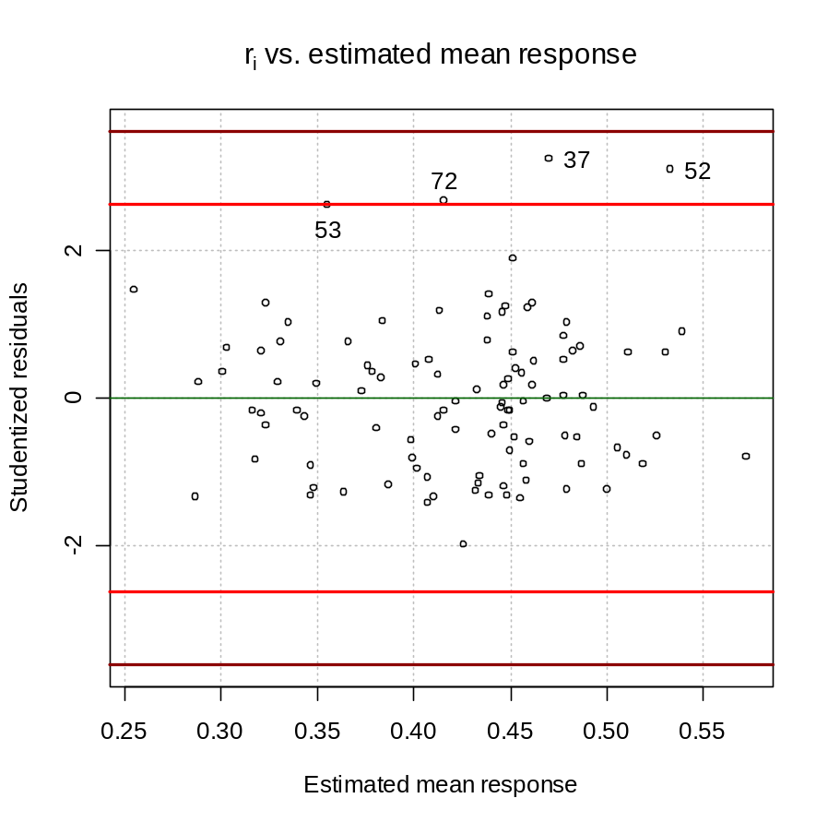

> #t.i vs. Y.hat.i
> plot(x = mod.fit$fitted.values, y = t.i, xlab =
"Estimated mean response", ylab = "Studentized
deleted residuals", main = expression(paste(t[i],
" vs. estimated mean response")), panel.first =
grid(col = "gray", lty = "dotted"), ylim =
c(min(qt(p = 0.05/(2*n), df = mod.fit$df.residual-
1), min(t.i)), max(qt(p = 1-0.05/(2*n), df =
mod.fit$df.residual-1), max(t.i))))
> abline(h = 0, col = "darkgreen")
> abline(h = c(qt(p = 0.01/2, df = mod.fit$df.residual-
1),qt(p = 1-0.01/2, df = mod.fit$df.residual-
1)), col = "red", lwd = 2)
> abline(h = c(qt(p = 0.05/(2*n), df =
mod.fit$df.residual-1),qt(p = 1-0.05/(2*n), df =
mod.fit$df.residual-1)), col = "darkred", lwd = 2)
> identify(x = mod.fit$fitted.values, y = t.i)
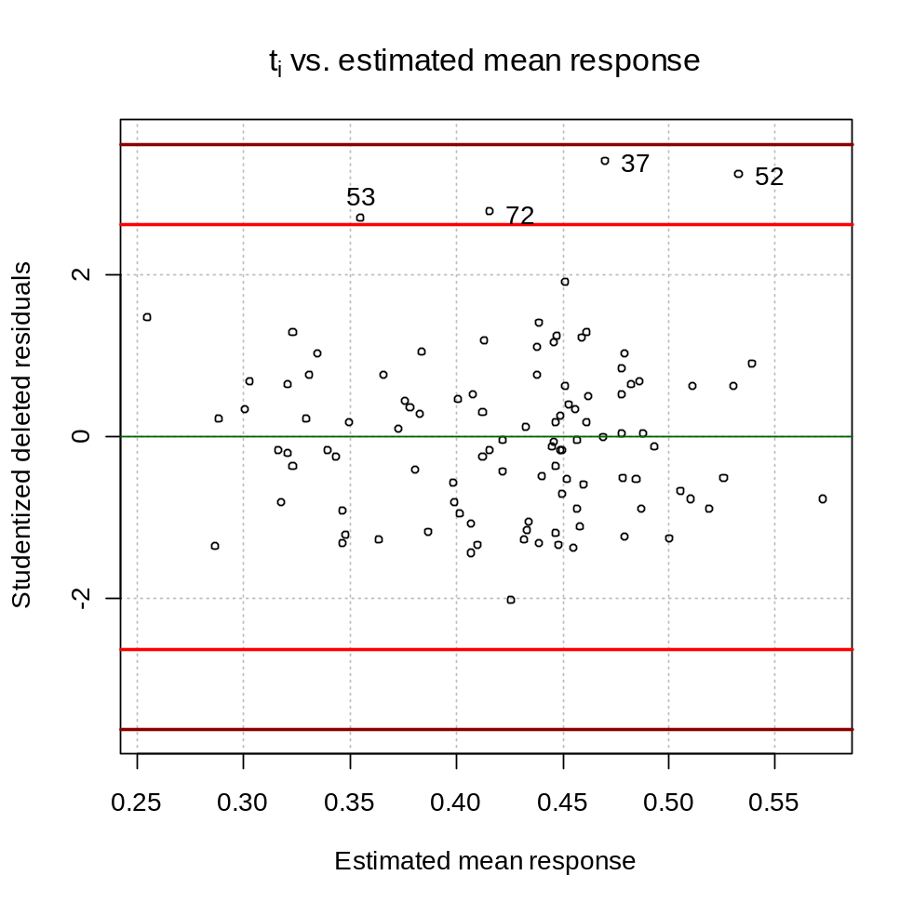

> #Fox and Weisberg's outlierTest() function gives the Bonferroni
adjusted p-value for the largest in absolute value
studentized deleted residual
> outlierTest(model = mod.fit)

No Studentized residuals with Bonferonni p < 0.05
Largest |rstudent|:
rstudent unadjusted p-value Bonferonni p
37 3.385149 0.001021 0.10721

> t.i[37]
37
3.385149

> #Unadjusted
> 2*(1-pt(abs(t.i[37]), df = mod.fit$df.residual - 1))
37
0.00102104

> #Adjusted
> 105*2*(1-pt(abs(t.i[37]), df = mod.fit$df.residual - 1))
37
0.1072092

Notes:
- The r_{i} vs. should be used instead of the vs. plot to check for outliers.
- Using critical values without Bonferroni adjustments produces a few potential outliers. Using critical values with Bonferroni adjustments does not produce any outliers. These potential outliers should be examined more closely (we will later). Notice the difference between the critical values!
- In general, a Bonferroni adjusted p-value (done here by the outlierTest() function) just takes a regular p-value and multiplies it by g (number of tests performed). This can be compared then to the usual α level to determine reject or not reject. Note that the help for outlierTest() says that it uses studentized residuals. However, you can see from the implementation of the function it is actually using studentized DELETED residuals.

10.3 Identifying outlying X observations – hat matrix leverage values

The diagonal elements of the hat matrix, h_{ii}, are useful in detecting outlying X observations.

h_{ii} is a measurement of distance (not Euclidean) of the i^{th} observation to the mean (center) of all observations. The “farther away” from the mean, the larger the h_{ii}. See Figure 10.6 of KNN.

Example: Advertisement responses (ad_responses_ch10.R)

This is the same example from Chapter 6. The purpose is to use size (inches²) of an advertisement and the circulation (10,000) of the newspaper to predict the number of advertisement responses.

Ad. Responses | Size | Circulation
100 | 1 | 20,000
400 | 8 | 80,000
100 | 3 | 10,000
300 | 5 | 70,000
200 | 6 | 40,000
400 | 10 | 60,000

The h_{ii} values are obtained using the hatvalues() function in R.

> ad.responses<-c(100, 400, 100, 300, 200, 400)
> size<-c(1, 8, 3, 5, 6, 10)
> circulation<-c(20000, 80000, 10000, 70000, 40000, 60000)

> set1<-data.frame(ad.responses, size, circulation)
> mod.fit<-lm(formula = ad.responses ~ size + circulation,
data = set1)

> h.ii<-hatvalues(model = mod.fit)
> h.ii
1 2 3 4 5 6
0.5472759 0.4551845 0.5270650 0.5678383 0.2260105 0.6766257

Below is a plot of the size vs. circulation (see program for code).
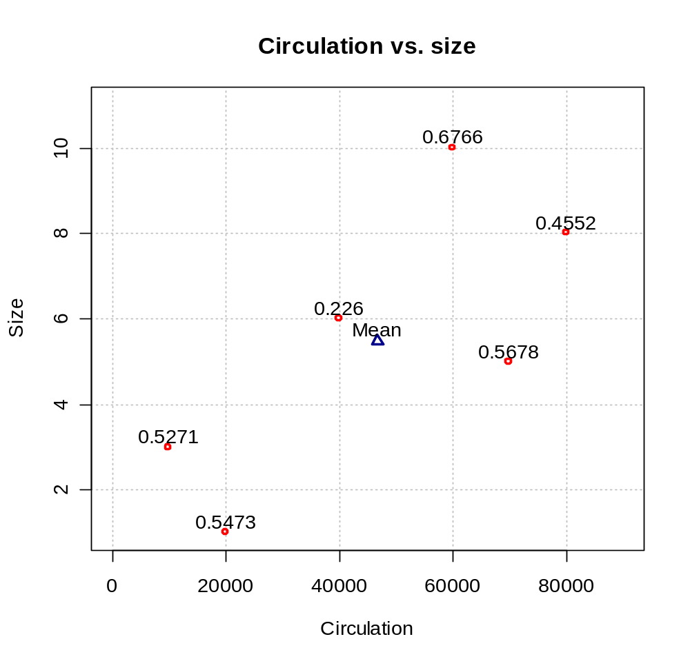
The values plotted with the points are the actual h_{ii} values. Notice that as the points get farther from the mean, the h_{ii} values generally increase. Be careful with the interpretation of the above plot since size and circulation are on different scales.

Notes:
- Properties of h_{ii}’s: 0 ≤ h_{ii} ≤ 1 and 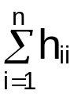 = p (check this for the last example)
- h_{ii} is often called the “leverage” of the i^{th} observation.
- If the i^{th} observation is outlying in terms of the X values, it has substantial leverage on determining the value for . This is a good way to think of the “distance” from the mean for the h_{ii}.
- The closer to 1 that h_{ii} is, the more important Y_{i} is to determining . Remember that ; i.e., is a linear combination of h_{ii}’s.
- The larger the h_{ii}, the smaller the denominators of r_{j} and t_{i} since
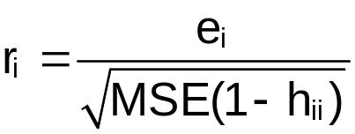 and 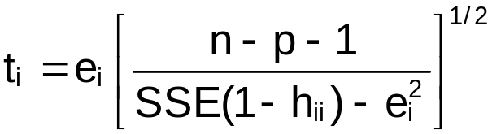. Examine what happens in the extreme case of h_{ii} close to 1.
- Since the sample regression line is pulled toward observations with high leverage, e_{i} may not be large relative to the rest of the residuals.
- Rule of thumb for determining if h_{ii} is “large”:
  - h_{ii} > 2p/n where p/n is the mean of h_{ii}
  - h_{ii} > 0.5 indicates very high leverage, 0.2<h_{ii}≤0.5 indicate moderate leverage.
These rules apply only when the sample size is “large” relative to the number of parameters in the model (see KNN example on p. 399-400).
- Large h_{ii} are values are not necessarily bad!
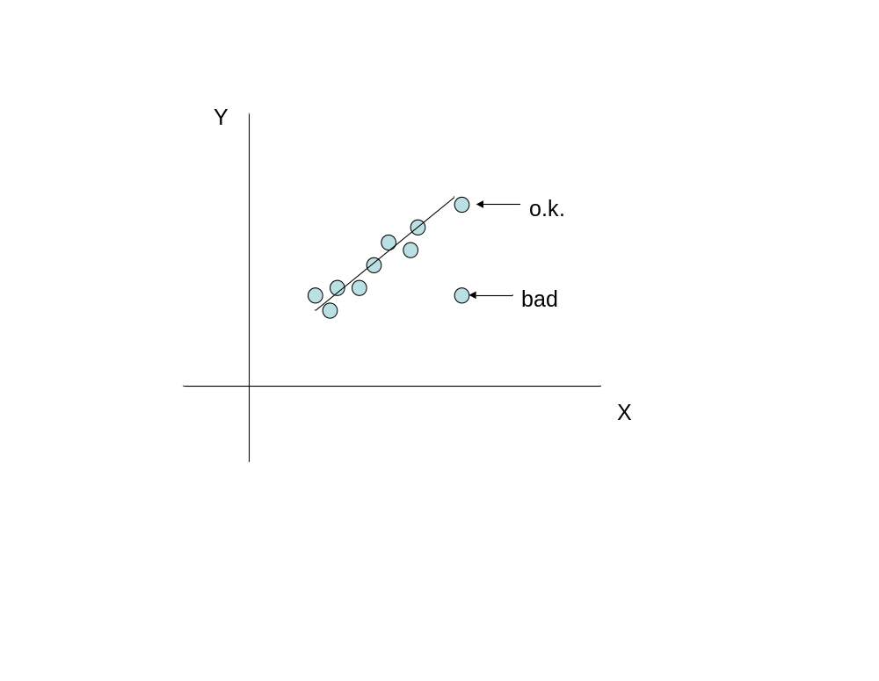
- Read “Use hat matrix to identify hidden extrapolation” on your own.

Example: HS and College GPA data set (HS_GPA_ch10.R)

Suppose the following value is added to the data set
(HS GPA, College GPA) = (X, Y) = (4.35, 1.5). Therefore, the student had a good GPA in HS, but a low GPA in college.

> #Read in the data
> gpa<-read.table(file =
"C:\\chris\\UNL\\STAT870\\Chapter1\\gpa.txt",
header=TRUE, sep = "")
> #head(gpa)

> gpa2<-rbind(gpa, data.frame(HS.GPA = 4.35, College.GPA =
1.5))
> mod.fit<-lm(formula = College.GPA ~ HS.GPA, data = gpa2)
> summary(mod.fit)

Call:
lm(formula = College.GPA ~ HS.GPA, data = gpa2)

Residuals:
Min 1Q Median 3Q Max
-1.81158 -0.25298 0.06158 0.32463 0.66473

Coefficients:
Estimate Std. Error t value Pr(>|t|)
(Intercept) 1.1203 0.3492 3.208 0.00463 **
HS.GPA 0.5037 0.1237 4.072 0.00065 ***
---
Signif. codes: 0 '***' 0.001 '**' 0.01 '*' 0.05 '.' 0.1 ' ' 1

Residual standard error: 0.5461 on 19 degrees of freedom
Multiple R-Squared: 0.466, Adjusted R-squared: 0.4379
F-statistic: 16.58 on 1 and 19 DF, p-value: 0.0006496

> h.ii<-hatvalues(model = mod.fit)

> plot(x = gpa2$HS.GPA, y = gpa2$College.GPA, xlab = "HS
GPA", ylab = "College GPA", main = "College GPA vs. HS
GPA", panel.first = grid(col = "gray", lty = "dotted"),
lwd = 2, col = "red", xlim = c(0, 4.5), ylim = c(0,4))
> text(x = gpa2$HS.GPA, y = gpa2$College.GPA+0.1, labels =
round(h.ii,2), cex = 0.75)
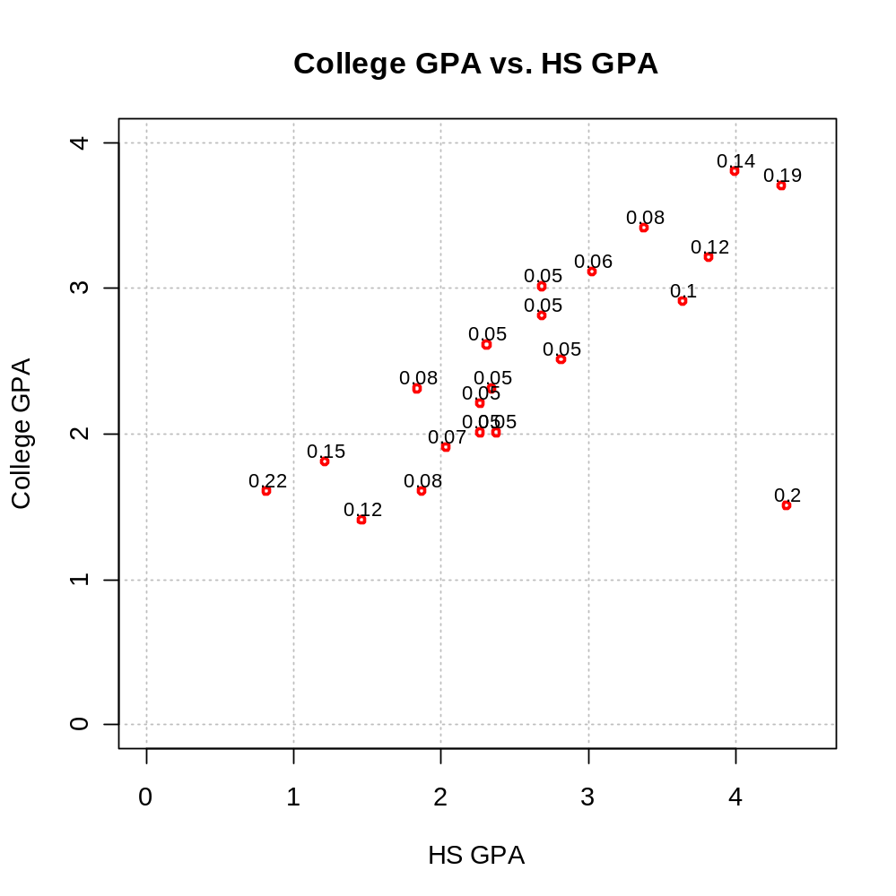

Notice that (4.35, 1.5) has a large h_{ii} relative to most of the other observations – although it is not the largest.

To compare the sample model with and without the (4.35, 1.5) observation, the plot below is produced. Notice that the estimated regression line is pulled toward (4.35, 1.5). The plotted h_{ii} values correspond to the model with (4.35, 1.5).

> #Put regression lines on plot
> curve(expr = mod.fit$coefficients[1] +
mod.fit$coefficients[2]*x, col = "darkblue",
lty = "solid", lwd = 1, add = TRUE, xlim =
c(min(gpa$HS.GPA), max(gpa$HS.GPA)))
> mod.fit.wo<-lm(formula = College.GPA ~ HS.GPA, data=gpa)
> curve(expr = mod.fit.wo$coefficients[1] +
mod.fit.wo$coefficients[2]*x, col =
"darkgreen", lty = "dashed", lwd = 1, add = TRUE,
xlim = c(min(gpa$HS.GPA), max(gpa$HS.GPA)))
> legend(locator(1), legend = c("Sample model w/ obs.",
"Sample model w/o obs."), col = c("darkblue",
"darkgreen"), lty = c("solid", "dashed"), bty =
"n", cex = 0.75)
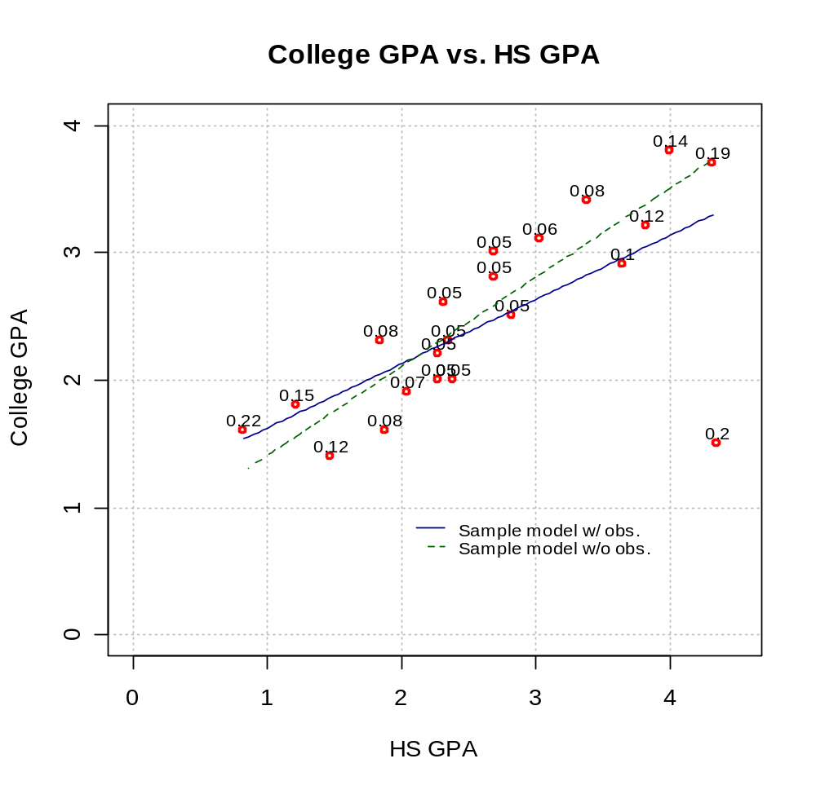

The extra observation has a lot of “leverage” with regards to being able to pull the estimated regression toward itself.

Below are two more plots. The left plot uses the additional observation of (4, 1.5) and the right plot uses (4.9, 1.5). Examine h_{ii} and the estimated regression line. The plotted h_{ii} values correspond to the model with the extra observation.

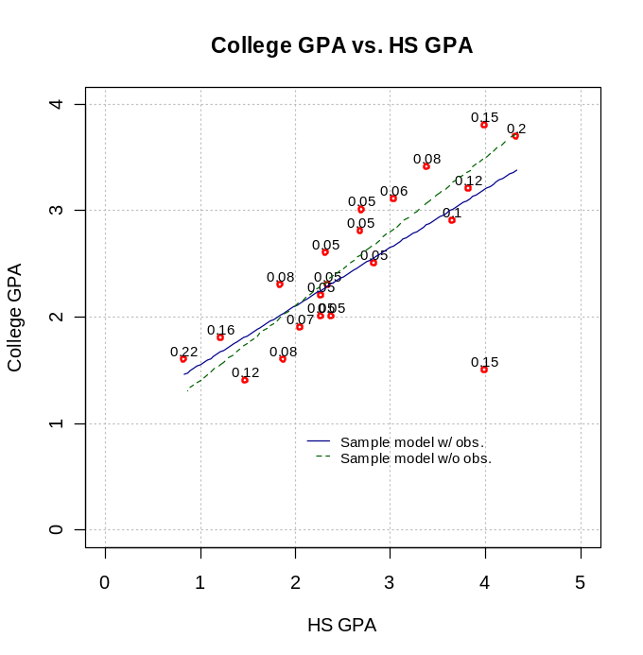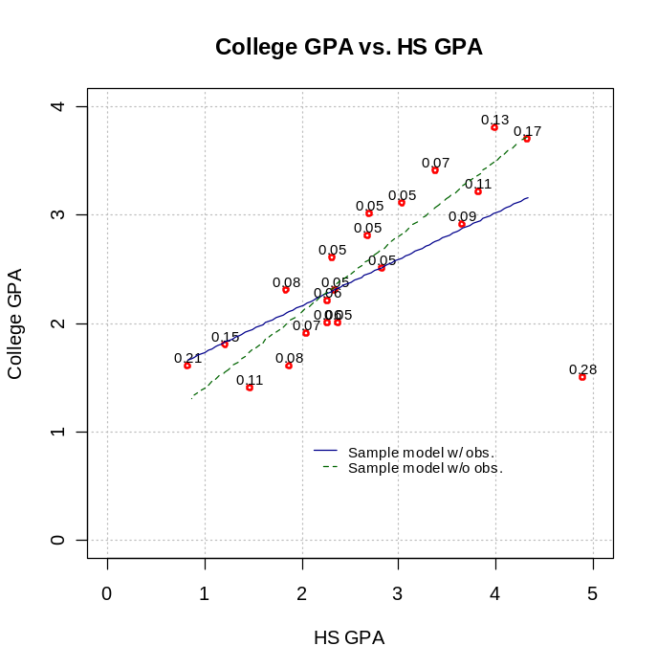

Example: NBA guard data (nba_ch10.R)

> h.ii<-hatvalues(model = mod.fit)
> p<-length(mod.fit$coefficients)
> n<-length(mod.fit$residuals)
> h.ii[h.ii>2*p/n]
> round(h.ii[h.ii>2*p/n],2)
7 14 21 24 37 48 98 104
0.15 0.20 0.17 0.10 0.11 0.21 0.11 0.10

> plot(x = 1:n, y = h.ii, ylab = expression(h[ii]), xlab
= "Observation number", main =
expression(paste("Index plot of ", h[ii])))
> abline(h = 2*p/n, col = "red", lty = "dashed")
> abline(h = c(0.2,0.5), col = "blue", lty = "dotted")
> identify(x = 1:n, y =h.ii)
[1] 7 14 21 24 37 48 98 104

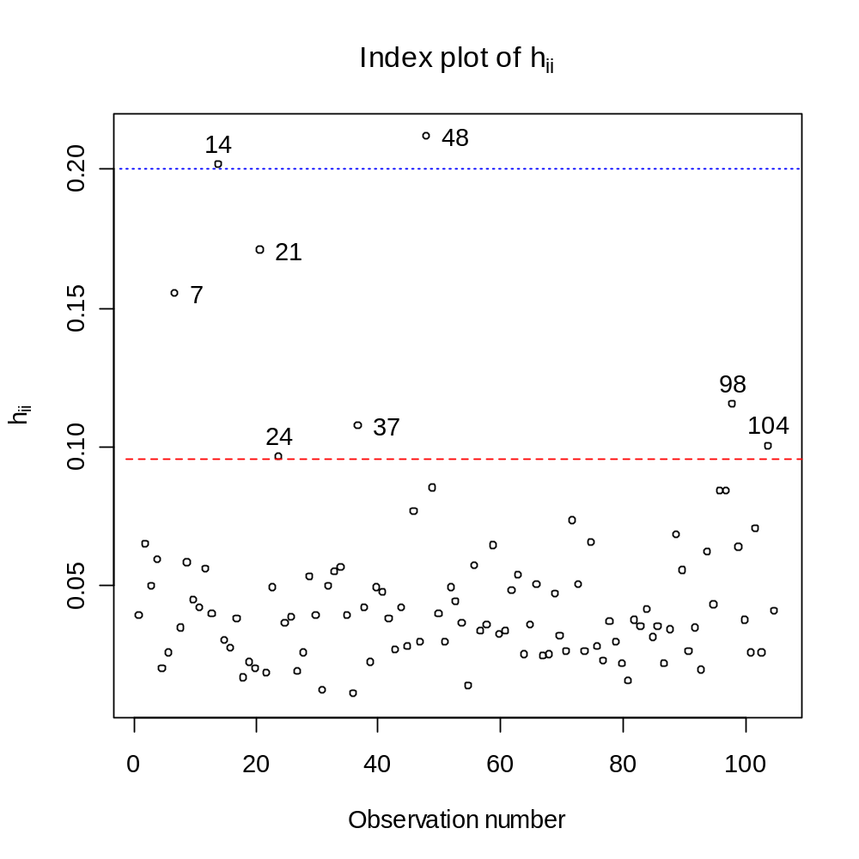
Horizontal lines are drawn at 2p/n = 2∗5/105 = 0.095, 0.2, and 0.5 to help show large h_{ii} values. More will be done with these observations later.

